**Sagi Rama Krishnam Raju Engineering College**

**DEPARTMENT OF COMPUTER SCIENCE AND ENGINEERING**

**ACCIDENT DETECTION AND COMMUNICATION SYSTEM**

Implementation of “Accident Detection and Communication System” using Deep learning for early medical help to accident victims.

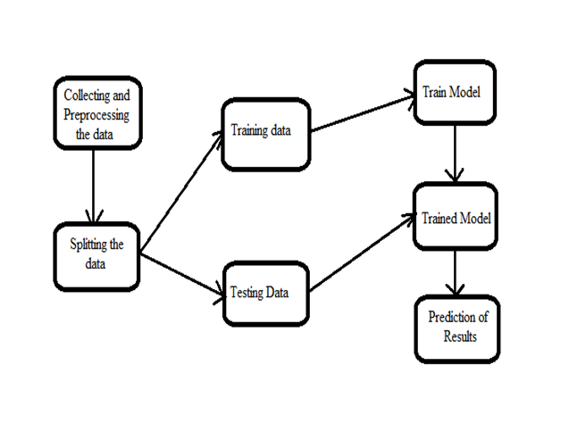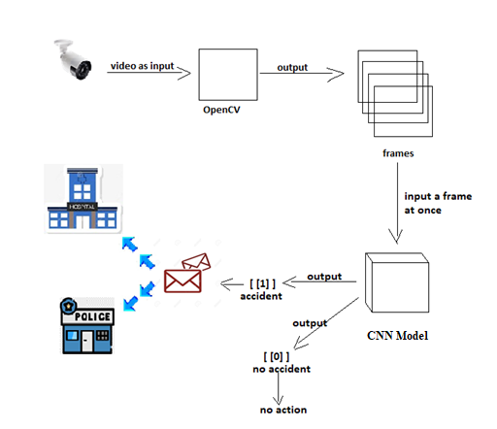

Fig.1: System Architecture Fig.2: Data Flow Diagram

Implementation: The OpenCV module takes the input from the traffic CCTV’s and extracts frames from the video. These frames will be given as input to the CNN model which will identify the accident and gives location details of the accident to the Communication module. The Communication module fetches the details of the location and sends mail to the nearest hospital using SMTP service.

**Conclusion:** An efficient Accident Detection and Communication System can help in reducing the number of deaths occurred due to lack of medical help. The proposed model can easily be extended for all types of vehicles after proper training and testing.